**What is AVID?**

Advancement via Individual Determination is an **elective** class where students will develop and reinforce attitudes, skills, and knowledge to successfully complete a college prep academic program in high school & thrive in college. Students are required to enroll in a rigorous course of study, maintain satisfactory grades, and outstanding citizenship while participating in AVID. AVID will focus on WICOR strategies (Writing, Inquiry, Collaboration, Organization and Reading) through:

|  |  |  |
| --- | --- | --- |
| Tutorials | Student Choice Book | Note-Taking Skills |
| Socratic Seminars | Test Prep | Public Speaking |
| Essay Writing | Organization Checks | College Research |

**Course Objective:**

Students will transition to the high school setting by focusing on academic and personal goals. Students will increase awareness of their personal contributions to their learning, as well as their involvement in school and the community. There is an emphasis on analytical writing, focusing on personal goals and thesis writing. Students will work in collaborative settings, learning how to participate in collegial discussions and use sources to support their ideas and opinions. Students will prepare for college entrance essays and placement exams, while refining study skills, test-taking, note-taking, and research techniques. They will take an active role in guest speaker preparations and presentations. Their college research will include financial topics and building their knowledge on colleges and careers of interest.

**Online Platform Used:** Google Classroom

**Required Materials/Resources:**

* School issued Chromebook with access to Classlink and Kami
* A binder/folder/notebook system in place to organize work and materials for EACH class
* Pencil pouch
* Colorful pens
* Pencils
* Colorful highlighters
* AVID agenda or a personal planner

**Average Week in Class:**

**M-** AVID Curriculum

**T-** Tutorial

**W-** AVID Curriculum

**Th-** Tutorial

**F-** Focused Notes, Backpack Organization and Binder Check

**Expectations and Tips for SUCCESS:**

* Remember you ELECTED to be in this class, it is not required; YOU choose to be here. Earn PBIS/ Bulldog Bucks by executing the 3 B’s

**AVID 9 Tentative Curriculum:**

**Fall-**

1. Growth Mindset
2. Life Goals
3. Community Service
   1. Service Project
4. Collaboration
5. Current Event Analysis
6. Personal Life Organization
7. AVID Write-Off

**Spring-**

1. Reflection
2. Time Management
3. Types of Learning and Personality Traits
4. Public Speaking
5. Goal Setting
6. College Project
7. 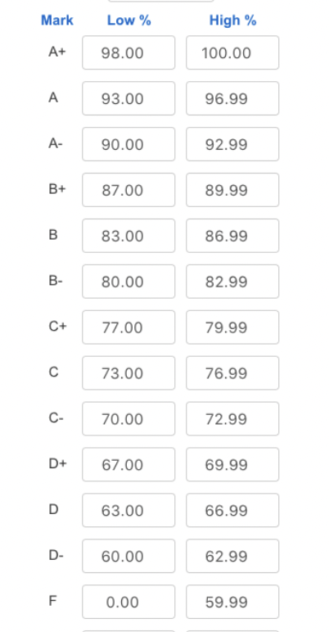Career Research

**Grading Policies:**

* Projects
* Essays
* Classwork
* Tutorials
* Organization Checks
* Focused Notes
* Quick-writes
* Discussions

**Missing and Late Work Policy:**

* Late work is excepted only if student received an extension prior to due date (including IEPs and 504 plans).
* Absent Work: You have the same number of days absent to make up missed work for up to full credit.

**Communication:**

Google Classroom is updated as needed, daily/weekly with assignments, resources, and announcements. I am available via email and through Google Classroom comments.

**Plagiarism/Academic Dishonesty:**

1. First Offense- Student(s) will be given a zero on the assignment if found to cheat or plagiarize and will be documented in Aeries comments.
2. Second Offense- Student(s) will be sent to the Assistant Principal’s Office and will be given a zero on the assignment which will be documented in Aeries comments.

**Supplemental Materials to be used:**

This list is not exhaustive, but covers the majority of supplemental materials used in class:

* Kahoot
* Khan Academy
* Ted Ed
* Discovery Channel
* BBC
* National Geographic
* Crash Course
* Reputable news outlets and websites
* A parent-approved young adult-oriented motivational silent reading book

**Consequences (to infractions on the Classroom Behavior Matrix)**

Level 1  -  Counsel student

Level 2  -  Contact parent, loss of points

Level 3  -  Contact parent and assistant principal

Level 4  -  Referral to AP office

Classroom Expectations - The 3 Bs

|  |  |  |  |
| --- | --- | --- | --- |
|  | BE  RESPECTFUL | BE  RESPONSIBLE | BE  SAFE |
| **IN CLASS** | * Remove hats/hoods to enter the class * Greet teacher and peers upon entry * One person speaks at a time * Respect differing opinions * Ask permission to leave your seat | * Be on time * Bring necessary materials * Be attentive and focused * Take notes / Be productive * Participate in class * Use Chromebook for academic purposes only | * Wipe down desk upon entry * Wash/sanitize hands often * No eating in class * Sit in assigned seats * See something (unsafe, unkind, suspicious), say something |
| **USE OF TECHNOLOGY** | * Use polite & scholarly language in emails & Remind communication * Always include full name/class period in messages * Include name, class period, and date on all work | * No cell phones/Avoid distractions * Charge Chromebook nightly at home * Bring Chromebook to class daily * Pace yourself and check assignments daily to complete work on time | * Do NOT share login information, passwords, or personal codes with anyone * Click on trustworthy links/sites. * Seek help sooner rather than later if issues arise |
| **ASSIGNMENT**  **COMPLETION** | * Do your best work * Use academic language * Maintain integrity * Do NOT copy or permit copying * Include name, class period, and date on all work | * Follow teacher’s instructions * Name/Date/Period on all work * Turn in assignments on time * Properly submit work with attachments and/or clear photos * Do your best work rather than just the minimum | * Maintain integrity * Avoid plagiarism * Double check that you attached files/submitted correctly * Talk to the teacher if you need additional help & reduce stress by completing work daily |
| **ASSESSMENTS** | * Follow teacher’s instructions * Do your best work * Maintain integrity * Do NOT copy or allow copying/ cheating of any kind | * Prepare for assessments through daily effort and review * Read all directions carefully * Complete & submit on time * Follow procedures for submitting essays (i.e. Turnitin.com) | * Maintain integrity * Avoid plagiarism * Do NOT screenshot or share your work with anyone * Do NOT look at others’ work |

**AVID 9 Syllabus, Argumosa** - Please sign below and return this page only.

**We have read, discussed, and understand the information presented in this syllabus.**

I ,__________________________________, certify that any and all written assignments turned into Mrs. Argumosa’s class are of my own creation. Any and all assignments turned into this class will be my original work and will not be plagiarized/stolen/copied. I understand that plagiarizing includes but is not limited to:

● Copying a friend’s work

● Copy/Pasting from the internet without citing the source

● Using a paper that a friend/family member wrote in the past

● Paraphrasing thoughts/ideas that are not mine without citing the source

● Any writing that is not of my own creation/thoughts

● Work “inspired” by my fellow classmates’ work

● A paid for essay from an app or website

● Anything written by a program/website including AI tools

● “If you use someone else’s words, you must put them within quotation marks unless directed otherwise by your instructor. If you rephrase someone else’s words, you should change the wording substantially AND cite the original source. Small changes are not enough to make someone else’s words or ideas your own” (source: Penn State).

By signing this I understand that my actions have consequences and if I am to turn in any work that is not my own, I will receive a zero on the assignment and not receive any chance to redo the assignment. I also understand that zeroes on my assignments can impact my grade heavily and possibly prevent passing the class and/or graduating on time as a result.

Student Name _________________________Student Signature ________________________________ ___________________________________

Parent Name _________________________ Parent Signature _______________________________

Parent Email__________________________________